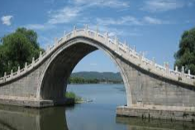
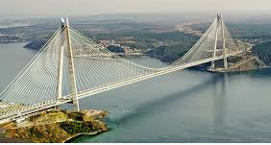
Springburn Academy Technology Department P7 to S1 Transition Exercise

STRUCTURES
In this exercise we are going to look at STRUCTURES such as the bridges above, then you are going to make a model that you can bring to your Technology Lesson after the summer holidays. You will do the following tasks over a few weeks.
Task 1
WE are going to do some research into the earliest bridges we had in this country. Find out as much as you can about the ARCH BRIDGE, and in particular the importance of the KEY STONE? Present all you work on paper with sketches or pictures to explain all about the ARCH BRIDGE
Task2
We are going to look at other STRUCTURES and in particular how they use LEVERS. Find out as much as you can about the 3 main types of LEVER and how they are used . Present all your finding on paper , and use coloured sketches or pictures to explain each LEVER type
Task 3
Now you are going to do some model making. Using materials you can find at home ( old newspaper, straws, card), make a model bridge and try to make it as strong a structure as you can. You will bring your model bridge to school after the summer holidays.

Questions or work should be sent to: gw10douglascolin@glow.sch.uk

