Springburn Academy

School Handbook 2020/2021

Dear Parent/ Carer,

We currently find ourselves in strange and uncertain times because of the Covid19 virus outbreak.

Despite this, we are working very closely with our primary colleagues to ensure that every young person’s transition from primary to secondary school will be as successful and supportive an experience as we can make it.

We had already embarked on our Transition Programme with our P7 Open Evening in September 2019, morning visits with their P7 classes during November/December and Pupil Support staff visiting their link Primary Schools throughout session 2019-2020 to meet with your child in their primary class and gathering transition information through speaking with their P7 teacher.

This handbook contains a range of information that you might find helpful. Over the coming weeks if you have any question, concerns or issues please send these to the Springburn Academy Headteacher email address and we will respond to you.

I hope that this handbook gives you a glimpse of life at Springburn Academy. I know that these are uncertain times and we are unclear about what returning to school will look like. I am however looking forward to meeting you and your child when it is safe for us to return and I hope that your child is as excited about joining Springburn Academy as we are about meeting and getting to know them.

Linda Hamilton
Head Teacher
School Vision & Values
School Vision: Success for All!

School Values: Respect - Education - Equality

In Springburn Academy we provide a welcoming and friendly environment, which celebrates the diversity of our community.

We aim to ensure that all pupils are successful learners, confident individuals, responsible citizens and effective contributors and prepared to take their place in society. This is achieved through working together with young people, their families and the community, based on a shared sense of direction.

School Information

You can cut out the following information and have it on your fridge, in your purse or on your work desk etc. for ease of finding the numbers required. It would be useful to note your child’s house on this too.

Contact Details:
HOUSE NAME:

151 Edgefauld Road
Glasgow
G21 4JL
Phone: 0141 582 0230
Email: headteacher@springburnacademy.glasgow.sch.uk
Website: www.springburnacademy.glasgow.sch.uk
@springburnacad @ht_Springburn

Absence line: 0141- 278-0039

Parent council contact:
@SpringburnAPC
springburnacademyparentcouncil@yahoo.co.uk

Associated Primary School: Barmulloch, Balornock, Chirnsyde, Elmvale, Miltonbank, Royston and Saracen.
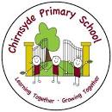
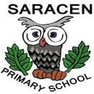
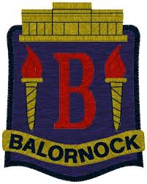

Springburn Academy is Springburn’s local non-denominational co-educational comprehensive school. It caters for pupils aged 12 – 18 (S1-S6) offering a wide range of courses. Springburn Academy has a capacity of 925 pupils - at present the roll is 850.

Springburn Academy is an inclusive and nurturing school that has children’s rights at its core.

Senior Leadership Team
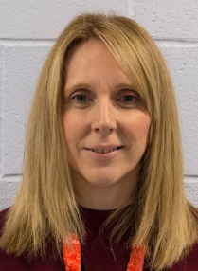
CP Officer
Head teacher DHT inclusion DHT S2/3 DHT S1/6 DHT S4/5
Mr L Hamilton Mr K Rae Ms K Watt Mrs A McCracken Temporary Vacancy

All staff in Springburn Academy has a clear responsibility for the welfare of young people. In addition, all young people are allocated to a house in the school where the House Pupil Support PT provides a vital link between home and school.

The House Pupil Support PT is the person you are most likely to have contact with if you have any concerns or information to share with the school.

Pupil Support PT – House
Mr S Smith Mr K Macpherson Mr G Donnelly Mrs S Johnston Mrs E Campbell
Burns House Clyde House Rowling House Wallace House Wallace House

Pupil Support PT - Additional Support Needs
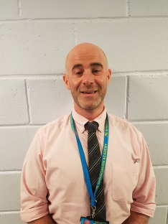
Mr P Connolly Ms K Sandilands Mr G Park
Behaviour Support Learning Support English as an Additional Language (EAL)

School staff
A full list is available on the school website and parents will be updated with any changes as they occur.

The School Day
Springburn Academy operates a 33 period week as follows:

Period 1 08.50-09.40
Period 2 09.40-10.30
Period 3 10.30-11.20
Interval 11.20-11.35
Period 4 11.35-12.25
Period 5 12.25-13.15
Lunch 13.15-13.55
Period 6 13.55-14.45
Period 7 14.45-15.35 (Monday, Tuesday and Thursday only)

Pupil Support

All young people in Springburn Academy have regular opportunities to discuss their learning and development with a teacher who knows them well and with whom they have a mutually trusting relationship. This is their Pastoral Care teacher.

Learning Community

Springburn Academy is part of a Learning Community which includes the 7 associated primaries, 2 nurseries and 2 ASL (additional support needs) establishments. All Heads of Establishments in the Community meet regularly and by working together this should allow pupils’ progress to be monitored from Nursery through to school leaving age.

All pupils in P6 and P7 will have an opportunity to visit the Academy (e.g. Parents’ Nights).

Balornock Primary School Head Teacher: Mrs L McSorley
Barmulloch Primary School Head Teacher: Mrs L Murray
Chirnsyde Primary School Head Teacher: Mrs J Maciver
Elmvale Primary School & Nursery Head Teacher: Mr G Macleod
Miltonbank Primary School Head Teacher: Ms G Robertson
Royston Primary School Head Teacher: Mrs J McShane
Saracen Primary School Head Teacher: Mrs E Gibson
Rockfield Nursery School Head Teacher: Ms R Stewart
Duntarvie Pre-School Assessment &
Development Centre Head of Centre: Ms R Bell
Broomlea Primary School Head Teacher: Ms F Shields

We welcome families from out-with our area. Families living out-with the school catchment area are welcome to make a placing request to attend Springburn Academy. Prospective parents are welcome to visit the school and should contact the school office. Further information is available on: http://www.goglasgow.org.uk/Pages/Show/1543

Curriculum

Springburn Academy is committed to providing its pupils with a wide and varied curriculum that offers opportunities for wider achievement and leadership activities for pupils from S1- S6 e.g., S1 mentors to House Captains in addition to academic learning.
The map below shows the allocation of periods to subjects through S1 to S6. (NQ means SQA National Qualification).

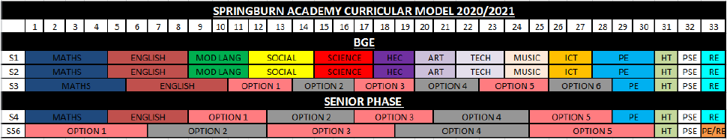

S1-S3
Pupils in S1 to S3 follow a broad general education in the following areas:

Expressive Arts | Health & Wellbeing | Languages | Mathematics
Religious & moral | Sciences | Social Studies | Technologies

This builds on the learning they have done at primary and allows for pupils to gain a deeper understanding of different subjects.

Literacy, Numeracy and Health & Wellbeing continue to be at the core of what pupils learn. We also place a strong emphasis on developing skills for learning, life and work throughout all our courses, including a number of inter-disciplinary experiences in all year groups.

Pupils in S3 will be able to specialise in areas that interest them most.

S4 –S6
As pupils move into S4 they will select the subjects they wish to study for S4-S6 that will lead to qualifications. Pupils will select subjects based on their likes, chosen career paths and ability, they, and you, will be supported to make the appropriate choices.

Homework
Your child will be issued with a Homework diary/ planner to record their homework and you will be asked to sign this every week. You can use this to communicate with your child’s teachers.

Homework is important to your child for many reasons:
- It helps to develop good work habits
- It helps to practice skills learned in class
- It can allow for personal research
- It shares what is being done in school with parents or carers
- It helps to show gaps in knowledge
- It helps you to see your child’s strengths and areas to develop
- Helps to develop independence.

You can help support your child’s learning by encouraging him/her to:
- Note when homework is due in the Diary/Planner
- Check that homework has been done in time
- Emphasise the importance of homework
- Discuss homework with him/her.

Other things that you can do to help with homework are:

- Establish a routine of when homework is done
- Try to give them a warm, well-lit, comfortable place to work
- Try to provide a place to work with no distractions, if possible
- Encourage him/her not to leave homework until the last minute
- Homework will be assessed in a variety of ways, sometimes graded sometimes comments designed to help and support your child.

Obviously the amount of homework and time required to spend on it increases as your child moves through school from S1 to S6. There is always space in school at supported study or in the Library for your child to complete homework if there is not a suitable place at home or if they prefer to do so.

Cost of the School Day

At Springburn Academy we are determined to keep any costs incurred by activities to a minimum however to offer as many different experiences as we can there are sometimes costs attached to activities. Examples of these are:

School trip - £3 for bus hire (there are other trips that cost more, foreign trips etc. but there is always a facility to pay these trips in instalments).
Lockers – pupils can hire lockers for £5 refundable deposit and £10 annual charge, two friends could share this cost.
We keep all extra costs to yourself to a minimum and would never want a child to be unable to participate in an activity because they are unable to pay the costs, so if you ever feel your child is being excluded from and activity for this reason please contact the House PT and the school will try to support your child to be able to participate.

Wider Achievement

We have a wide range of activities that run between Monday – Friday to extend the learning experience. There are many lunchtime and afterschool activities on offer. The list constantly changes but our school website is updated to reflect this. Good links with community organisations and our Active Schools Co-ordinator, Mr Joe Brannan, are vital for the success of these programmes.

There are also many opportunities throughout the school year for pupils to become involved in wider achievement activities run by departments and staff. Some pictures of events that happened last year feature below.

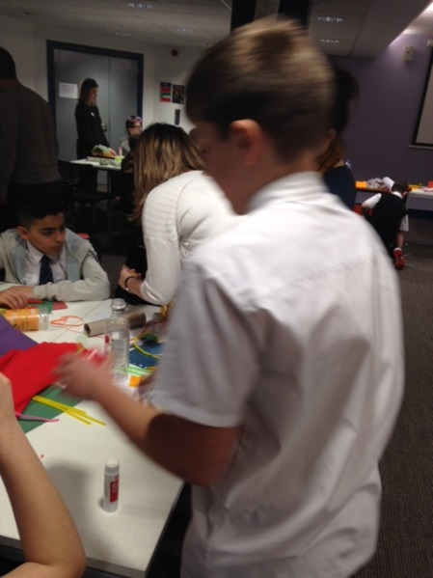
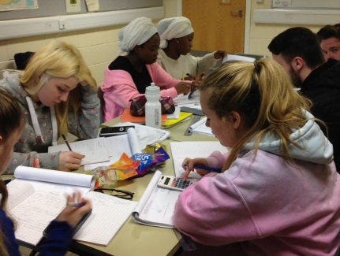

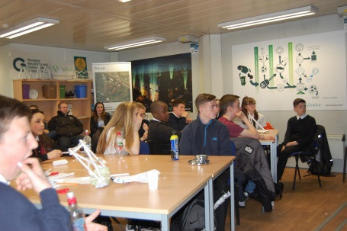

Assessment & Reporting
All young people are assessed both formally and informally throughout the school year. This allows young people and their teachers to identify their strengths and areas for improvement. A variety of assessment methods are used to enable staff to pass on information to parents and carers about the progress of their child. Assessment records are kept by teachers and form the basis of discussion at parents’ meetings throughout the year. Parents receive progress reports twice and get one full academic report each year. Parents will also be given the opportunity to meet their child’s teachers once a year. Dates of all parents’ meetings and the schedule for issuing progress reports is included in the school calendar which is issued at the start of term and is available on the website.

If you have any concerns about your child’s progress do not hesitate to contact their house pupil support teacher at any time.

Information on the Glasgow City Council’s Parental Involvement Strategy can also be found at www.glasgow.gov.uk

Pupil Profiles

As with P7 pupils all S3 learners have a profile which reflects their progress in learning and achievement with an emphasis their strengths. The profile documents their key achievements in school, at home and in the community and the content is decided by the young person. The profile provides a valuable way for learners to share information about their achievements with their parents, teachers and in the future, staff in colleges, universities and employers. The profile also supports the move from S3 into the senior phase of secondary school.

Religious & Moral Education
In today’s multicultural society, it is important to have an understanding of the different cultures and beliefs of the people who make up our community – in the wider sense.

Religious and Moral Education gives pupils the opportunity to study world religions (Judaism, Christianity, Islam, Hinduism, Buddism) and reflect on their beliefs. Religious and Moral Education should help pupils understand other people much better and help foster a more tolerant attitude in society.

Religious Observance

During the course of the year the school will host assemblies or events that highlight certain religious celebrations, including Christmas and Easter. Parents have the right to withdraw their child from religious observance and should inform the school in writing.

A parent can find out about the school’s curriculum at local and national level via:
- Education Scotland (Parentzone) http://www.educationscotland.gov.uk/parentzone/index.asp
- and SQA http://www.sqa.org.uk/sqa/CCC_FirstPage.jsp

Support for Pupils
The school has a duty to ensure that all pupils have equal access to the curriculum, with appropriate support for their needs if required. This applies to the content of lessons, teaching strategies and minor adaptations to the school environment. There are a wide range of factors which may act as a barrier to learning. We are committed to working closely with parents and carers to ensure that they are fully involved in any decisions about support for their children’s needs.

Any parent or carer seeking further advice regarding this policy should contact the Headteacher in the first instance.

The key principles of our support are contained in the Document ‘Getting it Right for every child’. Further information relating to additional support needs is available on the Glasgow City Council website –
http://www.goglasgow.org.uk/Pages/Show/1543

Library
The Springburn Academy Library is located in the heart of the School on the middle floor and our librarian is based there 3 days per week.

The Library is open after school for senior pupils to study - supervised by members of staff. The library is available at lunchtimes for pupils to use for study or borrow books.

Pupil Absence
Within Springburn Academy good attendance is encouraged at all times to ensure pupil success. Parents are asked to advise if their son or daughter is going to be absent. This should be done as early as possible on the first day of absence to the Pupil Absence Reporting Line on 0141 287 0039.

If the young person is going to be absent for some time, it would be helpful if you could inform your child’s House PT at the earliest opportunity. Arrangements can then be made for appropriate work to be sent home to try to minimise the impact of the absence.

The school uses daily text messaging to inform parents and carers of a young person’s absence if no contact is made. All unexplained absence is investigated by the school and appropriate action taken.

If your child has an unavoidable appointment, please give them a letter for their House PT to ensure that they have permission be absent from class. If an unforeseen appointment occurs please inform the absence line on 0141 287 0039.

Holidays during term time are discouraged and are recorded as an absence.

Attendance and Time Keeping

There is a strong link between attendance and exam success. THE CHILD WHO ATTENDS will achieve. In Springburn Academy period by period registration is recorded throughout the day. House PTs monitor attendance and time-keeping and parents are kept up-to date with any issues or concerns.

In cases of persistently low attendance Mrs N Feeney, Education Liaison Officer, will visit homes to investigate absences and will liaise with Pupil Support to discuss any support families may require with this.

In cases of very poor attendance, the Education Authority has the power to write to, interview or prosecute parents. Pupils can also be referred to the Reporter of Children’s Hearings for poor attendance.

School Dress Code

Our school uniform promotes a real sense of school identity, shared values, self-confidence and a shared sense of community. The uniform is actively supported by our pupils, parents and the Parent Council and is of great benefit to our young people. Dress Code promotes safety and security for everyone – any intruders can be quickly identified.

School Uniform
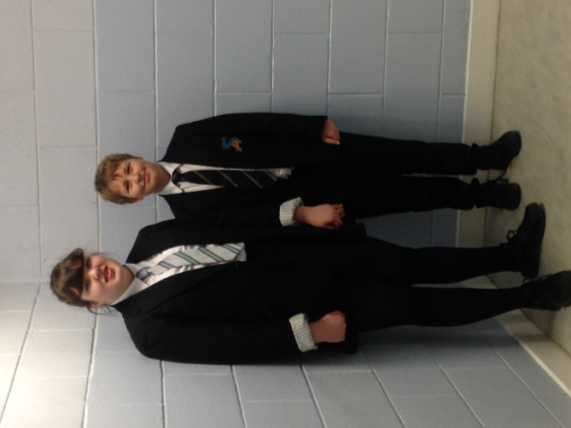
Blazer
White shirt
School tie – black stripe (junior) – silver stripe (senior)
Black trousers or skirt
Black footwear

Pupils should not wear:
Jeans (denim or black)
Leggings
Hoodies
Football colours
PE Kit
Black, Navy, or Blue shorts, leggings or jogging bottoms and the Springburn Academy blue t-shirt for juniors, black T-shirt for seniors, these are available to buy from the School Office. No football colours are allowed.

It is important that pupils come prepared to learn and in PE this requires appropriate clothing. All jewellery should be removed. Pupils who are not participating in PE must have a note or a medical certificate. Pupils who are unable to participate in practical PE should still bring their kit to allow them to assist in the lesson by refereeing, keeping scores or assisting with the distribution of equipment. This ensures that they are still able to take part in some way in the work of the class and do not miss out on the knowledge and understanding of the course.

Parents/Carers receiving any benefits will normally be entitled to monetary grants for footwear and clothing for their children. The local Job Centre will be able to advise you of what you can claim. Information and application forms may be obtained from schools and at http://www.goglasgow.org.uk/pages/show/1295

School Meals
Catering Direct provides refreshment in the school canteen or Fuel Zone before school starts, at the morning interval and at lunch time. A full school dinner of main, fruit/ yoghurt and a drink costs £1.90. The Fuel Zone uses a card system (Q-card or Young Scot card) for payment as well as cash. Pupils can put money into machines in the Fuel Zone – swipe the card and then use the card in the Fuel Zone, anyone entitled to a free meal will have money automatically credited to the card. Q-cards can be used at any time in the fuel zone, interval or lunch.

Information and application forms for free school meals may be obtained from the school office and at http://www.goglasgow.org.uk/pages/show/1295

Pupils may eat packed lunches in the canteen area. Food purchased from take-out establishments around the school (e.g. Chinese) is not allowed to be consumed in the Fuel Zone. It is school policy for S1 pupils to stay on school premises at interval and lunchtime.

Transport

The education authority has a policy of providing free transport to all young people who live out-with a certain radius from their local school by the recognised shortest walking route. This means that the provision of transport could be reviewed at any time. Parents/Carers who consider they are eligible should obtain an application form from the school or at http://www.goglasgow.org.uk/pages/show/1295. If you live more than a 2 mile walk from the school you could be eligible for a bus pass please check the website.

Assemblies
House assemblies and year-group assemblies take place every few weeks. Year- group assemblies will be led by the year DHT. House Assemblies led by the House PT and the House captains.

Assemblies are used to recognise good work and celebrate success but also to inform pupils of important issues that are appropriate to their year or house.

Partnership with Parents
To ensure success, it is vital that parents and staff at Springburn Academy work together. To enable our young people to reach their full potential the school must work in partnership with parents.

Termly newsletters are issued to all parents updating all homes with school news. The school will regularly send text messages to parents alerting them to upcoming events and about communications coming home via your child.

Parents can also support their child by attending parents’ evenings, open evenings, school events and by responding to any school consultation. If you need to contact the school about your child you should contact your child’s House PT by phone, email or note.

School Partnerships

Springburn Academy has strong links with a number of partner agencies including our link Primary schools, Colleges, Universities and businesses. In line with current national policies on Developing the Young Workforce and Delivering Equity and Closing the Attainment Gap our partnership working is furthering our pupils’ chances in achieving a positive destination after school. Some of our partners offer invaluable mentoring to our young people to support them in a wide variety of areas including building their resilience to how to navigate a university/ job application. All of our partners are committed to supporting your children to achieve the best they can.

Some of the partners we are currently working with are: Social Work, Health & Psychological Services, Lifelink Youth, Fairbridge, Luddon, Kelvin College, NG Homes, Amey, Galiford Tri, McTaggart, Princes Trust, Duke of Edinburgh, University of Glasgow, University of Strathclyde, Glasgow Caledonian University, MCR Pathways, Bemas, Royston Youth Action, Barnardos, Strathclyde Police, Fire Services, Blues Group, YOMO and School of Hard Knocks.

Medical & Healthcare
The school nurse visits at various times during the year for vaccinations. Parents and carers are kept informed by letter. It is important to note that if your child is 12 years old they can consent to vaccinations themselves, we always ask for parental permission via letter but if this is not returned your child can consent themselves.

If your child becomes ill during the course of the school day, he/she may require to be sent home. Please ensure that you keep the school informed of all contact details including an emergency number.

Parents and carers should inform the school of any medical requirements relating to their child. If a young person requires medication during the school day, parents must complete the appropriate medical form. This is available on request from the school office.

Emergency Contact Information

At the start of each school session, parents and carers will be issued with the annual data check form. Please ensure that this is completed and returned to the school. It is also important that you let us know if there are changes to your telephone number(s) or to those of your emergency contacts throughout the year.

Emergencies
We make every effort to maintain a full educational service, but on some occasions circumstances arise which lead to disruption. Schools may be affected by, for example, severe weather, power failures. In such cases, we shall do all we can to let you know about the details of our closure or re-opening by using letters, texts and the local and social media etc.

Data Protection – use of information about children and young people and parents/carers

We collect information about children and young people attending school (and also about parents/carers, emergency contacts etc. provided in the annual data check) to allow us to carry out the Council’s functions as the education authority for the City of Glasgow. This may sometimes involve releasing personal information to other agencies and other parts of the Council, particularly in relation to child protection issues or criminal investigations, and it may also be used for research purposes (see the link below for more details regarding this).

Information held by the school is, in legal terms, processed by Glasgow City Council. The Council is registered as a data controller under the Data Protection Act 2018 and all personal data is treated as confidential and used only in accordance with the Data Protection Act, the General Data Protection Regulations, and the Information Use and Privacy Policy approved by the City Council. For more information on how we use personal information, or to see a copy of the Information Use and Privacy Policy, see
https://www.glasgow.gov.uk/index.aspx?articleid=18010

Education specific privacy statements can be accessed at https://www.glasgow.gov.uk/index.aspx?articleid=22069 .

Comments & Complaints

In Springburn Academy we aim to have positive relationships across our school community. However, if you have a comment or complaint about any aspect of school life, please contact the Headteacher in the first instance at Headteacher@springburnademygasgow.sch.uk . Glasgow City Council complaints procedures are available: www.glasgow.gov.uk

Customer Care Team
Customer & Business Services
Glasgow City Council
City Chambers
Glasgow G2 1DU
Tel: 0141 287 0900 e-mail : education.customerservices@glasgow.gov.uk

Nurturing City

The Glasgow City Council vision ‘towards the nurturing city’, puts building positive, trusting relationships at the core of our work. We ensure children, young people and families feel they belong, they are listened to and they are valued by embedding the principles of nurture across our early years, primary and secondary establishments.

Staff are trained in attachment and nurture which deepens understanding of child development and enhances effective practice by responding to the needs of all children and young people in a consistent and caring way. Nurture is a universal approach which builds resilience, helping to reduce the impact of adversity. Effective communication and collaboration with parents and carers builds an ethos of partnership working putting the child at the centre, fostering high quality learning contexts.

Each of our nurturing establishments contribute to the development of Glasgow as a nurturing city, creating safe environments which allow our children and young people to flourish by raising attainment and promoting positive mental health and wellbeing.

Promoting Positive Behaviour

Children’s Rights as outlined in the UNCRC (United Nations Convention on the Rights of the Child) are fundamental to a good school ethos. Adults in our school will work with young people to ensure they are aware of their rights and fully respect the rights of others. Therefore, the approach within Springburn Academy is to build a positive ethos that demonstrates care and respect for all.

The smooth running of Springburn Academy requires a high standard of behaviour from all within it. We appreciate the support of parents and carers in helping us to achieve this. All pupils are required to behave well and respect their own safety and that of others. This is also important on journeys to and from school.

Parent Council

Parents and Carers play a vital role in their child’s education. In recognition of this the Scottish Schools (Parental Involvement) Act 2006 both encourages and supports more parents, working in partnership with the school, to be involved in their child’s education.

The main aims of the Parent Council are to:

• Help parents become more involved with their child’s education and learning
• To welcome parents as active participants in the life of the school
• Provide easier ways for parents to express their views and wishes

Springburn Academy’s Parent Council meets with the Headteacher every six weeks. Meetings are lively, informal and focus on sharing information, ideas and concerns between parents and school. The Parent Council has a formal constitution. Membership is open to all parents and information about meetings can be found in school newsletters/school website/parent council/Facebook and Twitter.

It is important for all parents to know who their parent representatives are:

Mr Richard Porter, Chairperson
Mrs Alison Melrose, Vice Chairperson
Ms Karen Watt, DHT, school representative

Effective communication is a key objective of the Parent Council. Parental views are always welcomed and will be passed to the Council. Representatives from all pupil councils will be invited to provide feedback from their own group and help establish good communication between all stakeholders.

Minutes of meetings are available from the school office and they can be e-mailed if you wish.

Please contact Mr Richard Porter at the email address below if you want further information or would like to become a member of the Parent Council.

Springburn Academy Parent Council
@SpringburnAPC
springburnacademyparentcouncil@yahoo.co.uk

Pupil Council

Pupils meet regularly in their house groups to discuss matters that concern them and to advise school leadership of their opinion when important school decisions are to be made. The house pupil councils then pass their advice and points onto the House Captains and other representatives who attend the whole school Pupil Council with Mrs Hamilton, HT. The Pupil Council is consulted on all school decisions.

Health & Safety
Health and safety are important issues in any school. The Education Department of Glasgow City Council is responsible for the health and safety of all who work in Springburn Academy and all pupils who attend the Academy.

The Head Teacher and staff of the Academy are responsible for making sure that the various regulations and rules for Health & Safety are observed in the day-to-day running of the School.

Emergency regulations in the case of fire, rules for movement about the School (including use of corridors and stairways as well as entry to and exit from the School building) have all been drawn up to ensure pupil safety. It is in everyone’s interest that these rules are followed by all pupils.

For some subjects there are specific requirements e.g. Art & Design, Technical, Home Economics, PE and all Science subjects. These take the form of safety rules which must be observed by pupils when attending these subjects, e.g. wearing of safety glasses in Science and Technical, not wearing jewellery in PE.

Following Health & Safety rules are not optional but are for the benefit of all, both staff and pupils.

Child Welfare & Safety/ Child Protection Policy

All Educational Establishments must take positive steps to help children protect themselves by ensuring that programmes of health and personal safety are central to the curriculum and should have in place a curriculum that ensures that children have a clear understanding of the difference between appropriate and inappropriate behaviour on the part of another person, no matter who. You will be kept informed of the PSE programme which includes a health and personal safety programme for your child.

Springburn Academy creates and maintains a positive ethos and climate which actively promotes child welfare and a safe environment by:

- Ensuring that children are respected and listened to
- Ensuring that programmes of health and personal safety are central to the curriculum
- Ensuring that staff are aware of child protection issues and procedures
- Establishing and maintaining close working relationships and arrangements with other agencies to make sure that professionals collaborate effectively in protecting children.

Should any member of staff have concerns regarding the welfare or safety of any child they must report these concerns to the Child Protection Officer. If it is judged that there may be grounds for concern regarding the welfare or safety of any pupil the Child Protection Officer will advise the duty senior social worker at the local social work services area office of the circumstances. If any parent has concerns about a pupil of Springburn Academy they can also contact the Headteacher/Child Protection Officer to report this.

Mr K Rae is Depute Head Teacher with responsibility for Child Protection.

School Improvement

The Standards and Quality report will be used to share the overall exam performance of the school and highlights progress in key curricular areas such as literacy, numeracy and health & wellbeing. Our priorities for improvement are detailed in our School Improvement Plan which is discussed with our Parent Council. Any parent or carer seeking a copy of the plan can contact the school office or check out our website.

Useful addresses:

Useful addresses:

Mrs M McKenna Ms Gerry Lyons
Executive Director Area Education Manager
City Chambers East City Chambers East
40 John Street 40 John Street
Glasgow G1 1JL Glasgow G1 1JL

Mr Gilbert Davidson Mr Bob Doris
Councillor Constituency MSP
Glasgow City Council Glasgow Maryhill & Springburn
City Chambers G2 1DU 43 Atlas Road
Glasgow G2 1DU Glasgow G21 4TA

School Holiday dates are on the next page.

School Holidays 2020_2021

The full list of holidays for Session 2020-2021 are as follows:
August
- Tuesday 11 August 2020 (Return date for Teachers & In-Service Day)
- Wednesday 12 August 2020 (In-Service Day)
- Thursday 13 August 2020 (Return date for the pupils)
September Weekend
- Friday 25 September 2020
- Monday 28 September 2020
October
- Friday 9 October 2020 (In-Service Day)
- Monday 12 to Friday16 October 2020 (October Week)
December - Christmas and New Year
- Schools close at 2.30 pm on Tuesday 22 December 2020
- Wednesday 23 December 2020 to Tuesday 5 January 2021 (Christmas holidays)

Updated school term dates 2021
January
- Schools return on Wednesday 6 January 2021
February Mid-term break
- Monday 8 February 2021
- Tuesday 9 February 2021
- Wednesday 10 February 2021 (In-service day)
April - Spring Holiday (Easter)
- Schools close at 2.30 pm on Thursday 1 April 2021
- Good Friday 2 April 2021
- Easter Monday 5 April 2021
- Schools return on Monday 19 April 2021
May
- Monday 3 May 2021 (May Holiday)
- Thursday 6 May 2021 (In-Service day to coincide with Scottish Parliament Elections)
- Friday 28 May 2021 and Monday, 31 May 2021 (May Weekend)
June
- Schools Close at 1.00 pm on Thursday 24 June 2021

