Accessing my School Work from Home
Start from our school website home page www.springburnacademy.glasgow.sch.uk
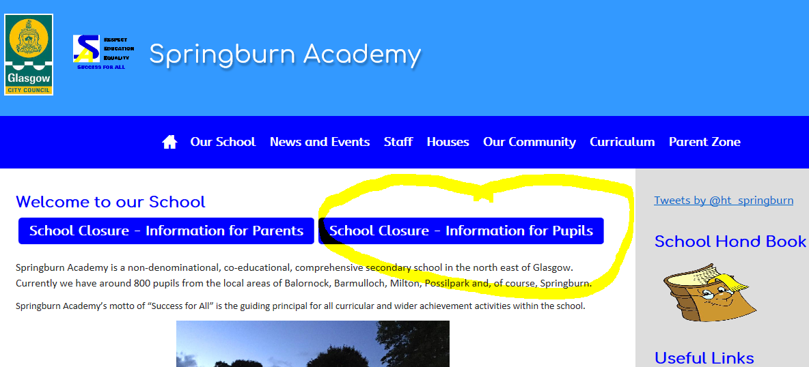
Step 1
Here you will see the school home page. Click on School Closure – Information for Pupils

Step 2
You will be taken to this page.
Click on Weekly Learning Plans and Resources

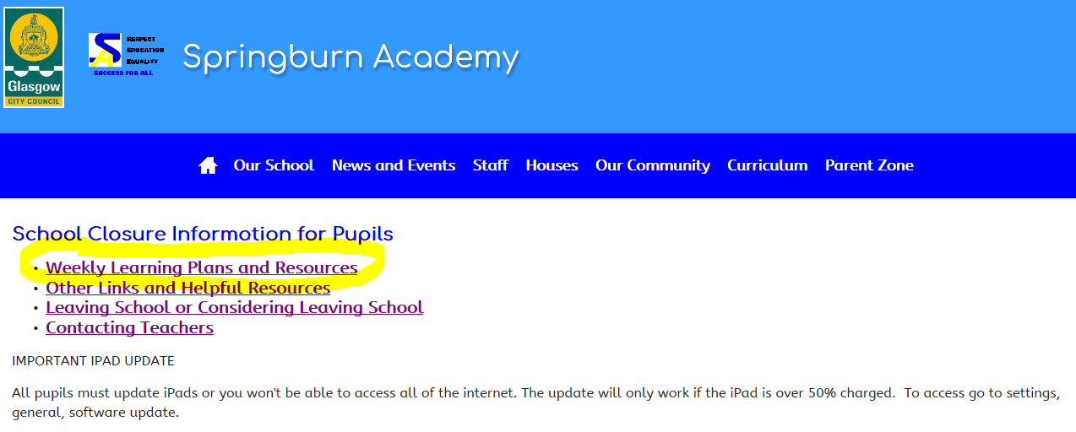
This page also contains other very helpful information.
Contacting Teachers – this will let you see when your teachers are available and how you can contact them.
Other Links and Helpful Resources has lots of interesting information, including guides on how to use Showbie and GLOW, and links to help you cope with lockdown and social isolation.
It is important to check this page regularly. For example, did you know there was an important update for pupil iPads? See the announcement at the bottom of this page.

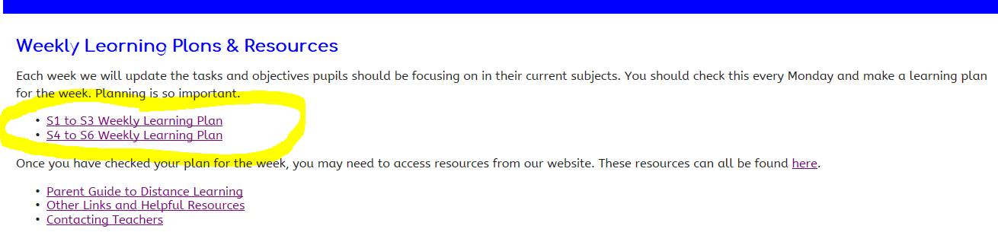
Step 4
This will open up a document with instructions on what you should be doing this week. All of the subjects are down the left hand side. The instructions are different for each subject so important you read all of them.

Step 3
You will be taken to this page.
Click on Weekly Learning Plans for your current year group.

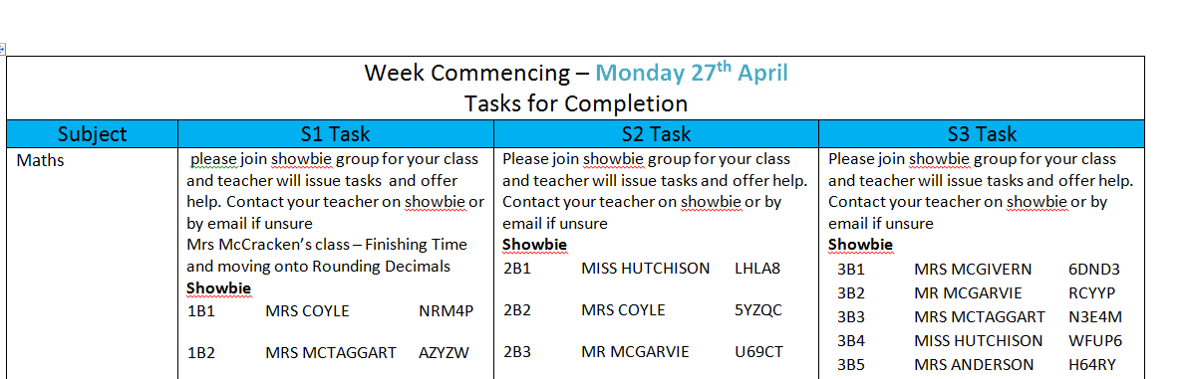
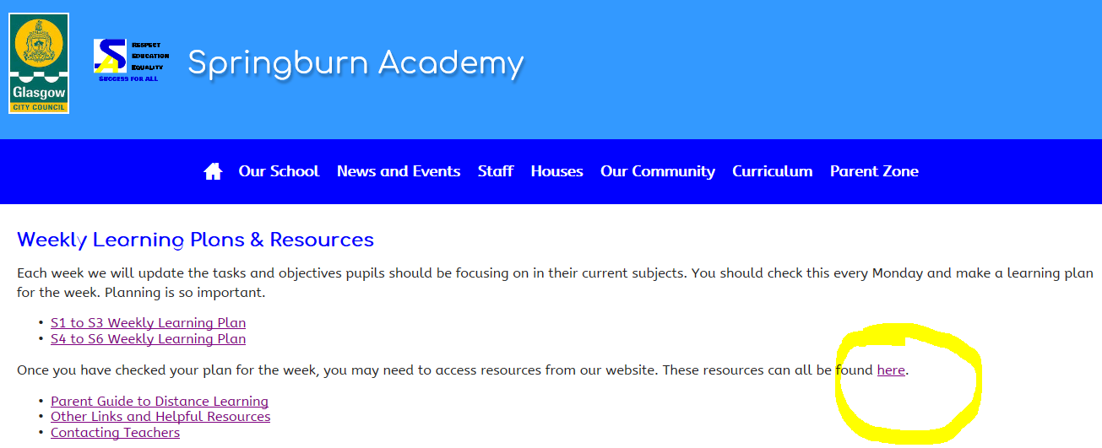
Step 5
The instruction may tell you to access a resource from the resource folder. To do this you must go back to the Weekly Learning Plans and Resources page and click on this link.
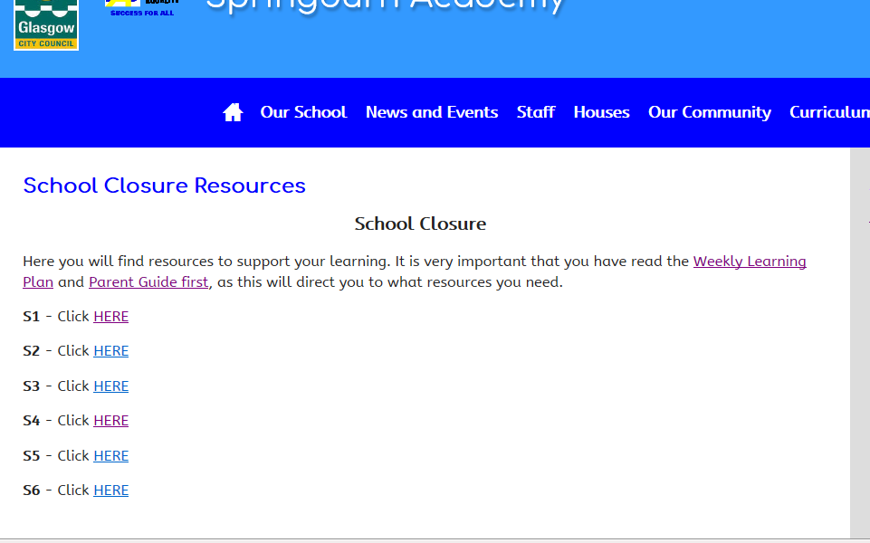
Step 6
This takes you to resources page. From here you need to click on your year group. You will then be asked for GLOW details. From there you can access all the department folders and access the work you need.

Frequently Asked Questions
- How much time should I spend on each subject?

- S1 to S3: you should be spending at least 3 hours per week on English and Maths, and between 1 and 2 hours on your other subjects.
- S4: you should be spending around 3 hours on each subject every week.
- S5/5: you should be spending around 4 and half hours on each subject every week.

- What if don’t understand an instruction or need help with a subject?

- Go to the Contacting Teachers link, find your teacher’s email them and ask!

- What if I don’t have any access to technology?

- Email headteacher@springburnacademy.glasgow.sch.uk Include your full name, House and Year Group.

- What if I am unwell and cannot do the work?
- Email you Pastoral Care teacher and let them know. Their email addresses are on the website under Contacting Teachers.

- What if I cannot remember my GLOW details?
- Email headteacher@springburnacademy.glasgow.sch.uk with your full name and we will have these reset.

- What if I don’t know how to use Showbie?
  - Watch this video https://www.loom.com/share/d5df954a9f504e69a96d93b23d3a11cf

- What if I’m not confident using GLOW or Teams
  - This document may help you. Or you could email your teacher.
http://www.springburnacademy.glasgow.sch.uk/Websites/SchSecSpringburn/UserFiles/file/making-the-most-of-glow-1585764423.pdf

